**Anomaly Detection on Machine Failures**

**Problem Formulation :**

Condition Based Maintenance (CBM) uses sensor to to collect real-time measurement (ie. pressure, temperature, and vibration). CBM data allows maintenance personnel to perform maintenance at the exact moment it is needed, prior to failure.

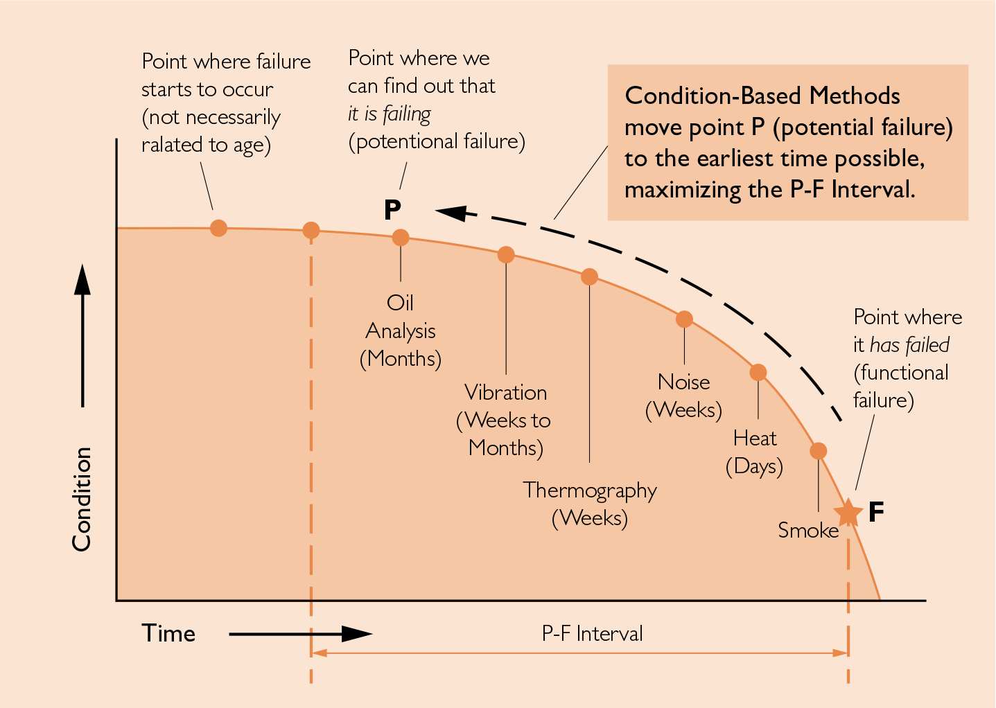

Benefit of CBM :

* Improved equipment lifespan
* Reduced cost of equipment maintenance
* Improved prioritization and utilization of maintenance time
* Fewer unplanned downtime events, higher equipment uptime

Up until recently when people spoke about Predictive Maintenance (PdM) this was essentially as a synonym for Condition Based Maintenance. But with the advent of Artificial Intelligence, much lower costs of equipment sensors (IIoT) and machine learning there is clearly a difference appearing between Predictive Maintenance (PDM) and Condition Based Maintenance (CBM). Predictive Maintenance as an extension, a more advanced approach to CBM where we use potentially many process parameters gained from online sensors to determine if our equipment is moving away from stable operating conditions and is heading towards failure.

**Dataset Description :**

We will use vibration sensor readings from NASA Acoustics and Vibration Database. sensor readings were taken on four bearings that were run to failure under constant load and running conditions. The vibration measurement signals are provided for the datasets over the lifetime of the bearings until failure. Failure occurred after 100 million cycles with a crack in the outer race.

**Submission :**

You have to build an anomaly detection model for vibration failure dataset. Upload your Notebook on your GitHub and send your repository link.